# Stations of the Cross

# Prayers of Penitence and Healing

# Peter Cullen

*Please gather at the First Station.*

# Opening Prayer

Priest: +In the name of the Father and of the Son and of the Holy Spirit. **Amen**

Almighty God, whose most dear Son went not up to joy but first he suffered pain, and entered not into glory before he was crucified: mercifully grant that we, walking in the way of the cross, may find it none other than the way of life and peace; through Jesus Christ your Son our Lord, who is alive and reigns with you, in the unity of the Holy Spirit, one God, now and for ever. **Amen**

# 1 Jesus is Condemned to Death

Priest: We adore you, O Christ, and we bless you

**All: For by your cross, you have redeemed and saved us.**

The chief priests and the elders, however, had persuaded the crowd to demand the release of Barabbas and the execution of Jesus. So when the governor spoke and asked them, 'Which of the two do you want me to release for you?' they said, 'Barabbas'. 'But in that case,' Pilate said to them, 'what am I to do with Jesus who is called Christ?' They all said, 'Let him be crucified! 'Why?' he asked, 'What harm has he done?' But they shouted all the louder. 'Let him be crucified!' Then Pilate saw that he was making no impression, that in fact a riot was imminent. So he took some water, washed his hands in front of the crowd and said. I am innocent of this man's blood. It is your concern.' And the people, to a man, shouted back 'His blood be on us and on our children!' Then he released Barabbas for them. He ordered Jesus to be first scourged and then handed over to be crucified.

Lord, for the times I have washed my hands of my responsibilities.

**Lord,** **have** **mercy.**

Lord, for the times I fail to have the courage to do what I know is right.

**Christ,** **have** **mercy.**

Lord, for the times I blame others for my actions,

**Lord,** **have** **mercy.**

Lord, heal my memories of those occasions when I have been wrongly accused, and help me forgive those who have judged me unjustly.

*As we walk to the next station, we sing:*

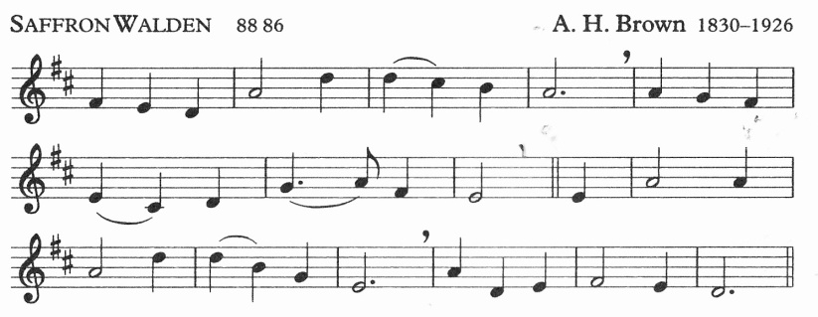

JUST as I am, without one plea

but that thy blood was shed for me,

and that thou bidst me come to thee,

O Lamb of God, I come.

# 2 Jesus Takes His Cross

Priest: We adore you, O Christ, and we bless you

**All: For by your cross, you have redeemed and saved us.**

The governor's soldiers took Jesus with them into the Praetorium and collected the whole cohort round him. There they stripped him and made him wear a scarlet cloak, and having twisted some thorns into a crown they put this on his head and placed a reed in his right hand. To make fun of him they knelt to him saying. 'Hail. king of the Jews!’ And they spat on him and took the reed and struck him on the head with it. And when they had finished making fun of him, they took off the cloak and dressed him in his own clothes and led him away to crucify him.

*(Matthew* *27:27-31)*

Lord, for the times I am disgruntled and complain about my lot,

**Lord,** **have** **mercy.**

Lord, for the times I mock and ridicule others,

**Christ,** **have** **mercy.**

Lord, for the times I punish others, loading them with burdens.

**Lord,** **have** **mercy.**

Heal me. Lord, of the injuries I've felt from the words and actions of others.

*As we walk to the next station, we sing:*

Just as I am, though tossed about

with many a conflict, many a doubt,

fightings and fears within, without,

O Lamb of God, I come.

# 3 Jesus Falls

Priest: We adore you, O Christ, and we bless you

**All: For by your cross, you have redeemed and saved us.**

It was essential that he should in this way become completely like his brothers so that he could be a compassionate and trustworthy high priest of God's religion, able to atone for human sins. That is, because he has himself been through temptation he is able to help others who are tempted.

*(Hebrews 2:17-18)*

Lord, for the times I have caused others to fall.

**Lord, have mercy.**

Lord, for the times I fail to show compassion,

**Christ, have mercy.**

Lord, for the times I am no support to my brothers and sisters.

**Lord, have mercy.**

Heal me, Lord, of the hurt my pride has suffered. Help me not to be too proud to ask forgiveness of those I have hurt.

*As we walk to the next station, we sing:*

Just as I am, poor, wretched, blind;

sight, riches, healing of the mind,

yea, all I need, in thee to find,

O Lamb of God, I come.

# 4 Jesus Meets His Mother

Priest: We adore you, O Christ, and we bless you

**All: For by your cross, you have redeemed and saved us.**

'Mary, do not be afraid: you have won God's favour. Listen! You are to conceive and bear a son, and you must name him Jesus. He will be great and will be called Son of the Most High. The Lord God will give him the throne of his ancestor David: he will rule over the House of Jacob for ever and his reign will have no end.'

*(Luke 1:30-33)*

Lord, for the times I have not accepted your Word

**Lord, have mercy.**

Lord, for the times I have allowed the troubles and trials of the day to get the better of me.

**Christ, have mercy.**

Lord, for the times I have been too full of my own importance.

**Lord, have mercy.**

Lord, heal me of all fear; give me the wisdom to know your will and the strength to carry it out.

*As we walk to the next station, we sing:*

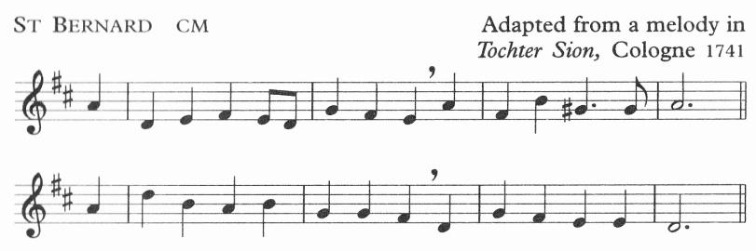

All ye who seek for sure relief

in trouble and distress,

whatever sorrow vex the mind,

or guilt the soul oppress;

# 5 Simon Helps Jesus

Priest: We adore you, O Christ, and we bless you

**All: For by your cross, you have redeemed and saved us.**

On their way out, they came across a man from Cyrene, Simon by name, and enlisted him to carry his cross

*(Matthew 27:32)*

Lord, for the times I fail to help carry other people's burdens,

**Lord, have mercy.**

Lord, for the times I fail to share whatever you have given me.

**Christ, have mercy.**

Lord, for the times I do not welcome strangers.

**Lord, have mercy.**

Lord, heal my lack of openness to others. Help me to make the first move to welcome others.

*As we walk to the next station, we sing:*

Jesus, who gave himself for you

upon the cross to die,

opens to you his sacred heart:

O to that heart draw nigh.

# 6 Veronica Helps Jesus

Priest: We adore you, O Christ, and we bless you

**All: For by your cross, you have redeemed and saved us.**

'For I was hungry and you gave me food; I was thirsty and you gave me drink: I was a stranger and you made me welcome: naked and you clothed me, sick and you visited me, in prison and you came to see me.' Then the virtuous will say to him in reply, 'Lord, when did we see you hungry and feed you; or thirsty and give you drink? When did we see you a stranger and make you welcome: naked and clothe you: sick or in prison and go to see you?' And the King will answer, I tell you solemnly, in so far as you did this to one of the least of these brothers of mine, you did it to me.'

*(Matthew 25:35-40)*

Lord, for the times I fail to see you in my neighbour,

**Lord, have mercy.**

Lord, for the times I fail to show hospitality,

**Christ, have mercy.**

Lord, for the times I fail to see the needs of others,

**Lord, have mercy.**

Heal me, Lord, of the prejudices that prevent me from reaching out to others.

*As we walk to the next station, we sing:*

Ye hear how kindly he invites;

ye hear his words so blest:

‘All ye that labour come to me,

and I will give you rest.’

# 7 Jesus Falls Again

Priest: We adore you, O Christ, and we bless you

**All: For by your cross, you have redeemed and saved us.**

Yet he was pierced through for our faults, crushed for our sins. On him lies a punishment that brings us peace, and through his wounds we are healed. We had all gone astray like sheep, each taking his own way, and Yahweh burdened him with the sins of all of us.

*(Isaiah 53:5-6)*

Lord, for the times I have wounded others,

**Lord, have mercy.**

Lord, for the times I have preferred to go my own way,

**Christ, have mercy.**

Lord, for the times I have exaggerated the faults of others,

**Lord, have mercy.**

Heal me, Lord, of all resentments. Help me to bring your peace and healing to those I have wounded.

*As we walk to the next station, we sing:*

O Jesus, joy of saints on high,

thou hope of sinners here,

attracted by those loving words

to thee we lift our prayer.

# 8 Jesus Consoles the Women

Priest: We adore you, O Christ, and we bless you

**All: For by your cross, you have redeemed and saved us.**

Large numbers of people followed him, and of women too, who mourned and lamented for him. But Jesus turned to them and said. 'Daughters of Jerusalem, do not weep for me: weep rather for yourselves and for your children...'

*(Luke 23:27 28)*

Lord, for the times I fail to comfort those in need.

**Lord, have mercy.**

Lord, for the times I am lacking in generosity.

**Christ, have mercy.**

Lord, for the times I do not listen to people.

**Lord, have mercy.**

Lord, fill with your healing love, each moment of my life where there has been a lack of love. Fill me with your love so that I may share it with others.

*As we walk to the next station, we sing:*

Wash thou our wounds in that dear blood

which from thy heart doth flow;

a new and contrite heart on all

who cry to thee bestow.

# 9 The Third Fall

Priest: We adore you, O Christ, and we bless you

**All: For by your cross, you have redeemed and saved us.**

He had not done anything wrong, and there had been no perjury in his mouth. He was insulted and did not retaliate with insults: when he was tortured he made no threats but he put his trust in the righteous judge. He was bearing our faults in his own body on the cross, so that we might die to our faults and live for holiness: through his wounds you have been healed. You had gone astray like sheep but now you have come back to the shepherd and guardian of your souls.

*(1 Peter 2: 22 24)*

Lord, for the times I have accused others falsely.

**Lord, have mercy.**

Lord, for the times I have been untruthful.

**Christ, have mercy.**

Lord, for the times I have retaliated unjustly.

**Lord, have mercy.**

Heal me, Lord, of all insults that have crippled me. Help me, Lord, to be gentle with others.

*As we walk to the next station, we sing:*

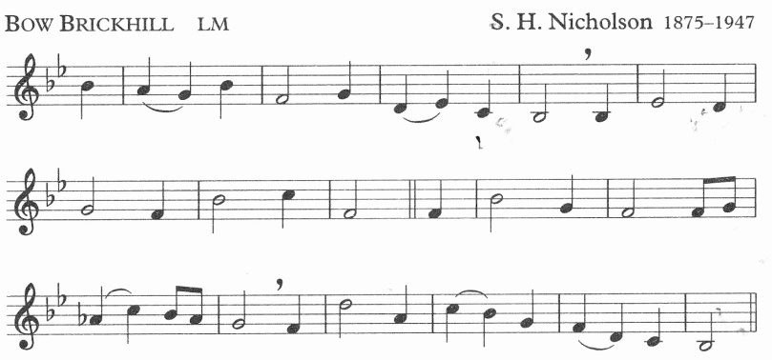

WE sing the praise of him who died,

of him who died upon the cross;

the sinner's hope let men deride,

for this we count the world but loss.

# 10 Jesus Is Stripped

Priest: We adore you, O Christ, and we bless you

**All: For by your cross, you have redeemed and saved us.**

They took his clothing and divided it into four shares, one for each soldier. His undergarment was seamless, woven in one piece from neck to hem: so they said to one another, 'instead of tearing it, let's throw dice to decide who is to have it'. In this way the words of scripture were fulfilled: "They shared out my clothing among them. They cast lots for my clothes."

*(John 19:23-24)*

Lord, for my immodest thoughts and actions.

**Lord, have mercy.**

Lord, for the sharpness of my tongue.

**Christ, have mercy.**

Lord, for my impatience with others,

**Lord, have mercy.**

Heal me. Lord, of all that I am ashamed. Drive all evil far from me. Lord.

*As we walk to the next station, we sing:*

Inscribed upon the cross we see

in shining letters, 'God is love';

he bears our sins upon the tree;

he brings us mercy from above.

# 11 Jesus is nailed to the Cross

Priest: We adore you, O Christ, and we bless you

**All: For by your cross, you have redeemed and saved us.**

When the reached the place called The Skull, they crucified him there and the two criminals also, one on the right, the other on the left. Jesus said. 'Father, forgive them: they do not know what they are doing.'

*(Luke 23:33 34)*

Lord, for the times I fail to forgive others.

**Lord, have mercy.**

Lord, for the times I crucify others.

**Christ, have mercy.**

Lord, for the times I turn my back on you,

**Lord, have mercy.**

Heal me, Lord, of all my jealousy, of all that hinders and cripples me.

*As we walk to the next station, we sing:*

The cross! It takes our guilt away:

it holds the fainting spirit up;

it cheers with hope the gloomy day,

and sweetens every bitter cup.

# 12 Jesus speaks to his mother

Priest: We adore you, O Christ, and we bless you

**All: For by your cross, you have redeemed and saved us.**

Near the cross of Jesus stood his mother and his mother's sister Mary the wife of Clopas, and Mary of Magdala. Seeing his mother and the disciple he loved standing near her. Jesus said to his mother, 'Woman. this is your son'. Then to the disciple he said. 'This is your mother. And from that moment the disciple made a place for her in his home.

*(John 19:25 27)*

Lord, for the times I do not welcome others into my life.

**Lord, have mercy.**

Lord, for the times I show disrespect to my mother and father, to my brothers and sisters.

**Christ, have mercy.**

Lord, for the times I devalue the life you give us.

**Lord, have mercy.**

Lord, heal my relationships with my parents and family and friends, and with all those with whom I share my life.

*As we walk to the next station, we sing:*

It makes the coward spirit brave,

and nerves the feeble arm for fight;

it takes its terror from the grave,

and gilds the bed of death with light.

# 13 Jesus Dies

Priest: We adore you, O Christ, and we bless you

**All: For by your cross, you have redeemed and saved us.**

It was now about the sixth hour and, with the sun eclipsed, a darkness came over the whole land until the ninth hour. The veil of the Temple was torn right down the middle, and when Jesus had cried out in a loud voice, he said. 'Father, into your hands I commit my spirit'. With these words he breathed his last.

*(Luke 23: 44 46)*

Lord, for the times I fail to give myself to you.

**Lord, have mercy.**

Lord, for the times I fail to commit myself to others.

**Christ, have mercy.**

Lord, for the times I fail to allow others to be themselves.

**Lord, have mercy.**

Heal me, Lord, with the power of your Spirit. May you so live in me that I may be used to give new life to those around me.

*As we walk to the next station, we sing:*

The balm of life, the cure of woe,

the measure and the pledge of love,

the sinner's refuge here below,

the angels' theme in heaven above.

# 14 Jesus Is Taken Down

Priest: We adore you, O Christ, and we bless you

**All: For by your cross, you have redeemed and saved us.**

After this, Joseph of Arimathaea, who was a disciple of Jesus though a secret one because he was afraid of the Jews asked Pilate to let him remove the body of Jesus. Pilate gave permission, so they came and took it away.

*(John 19:3S)*

Lord, for the times I fail to turn to you for healing.

**Lord, have mercy.**

Lord, for the times I fail to admit that I know you.

**Christ, have mercy.**

Lord, for the times my silence and inaction have offended or misled others.

**Lord, have mercy.**

Heal me, Lord, of all humiliation. Make of me the person you want me to be.

*As we walk to the next station, we sing:*

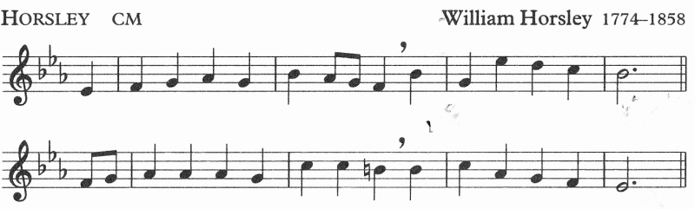

There is a green hill far away,

without a city wall,

where the dear Lord was crucified,

who died to save us all.

# 15 Jesus Is Buried

Priest: We adore you, O Christ, and we bless you

**All: For by your cross, you have redeemed and saved us.**

They took the body of Jesus and wrapped it with the spices in linen cloths, following the Jewish burial custom. At the place where he had been crucified there was a garden, and in this garden a new tomb in which no one had yet been buried. Since it was the Jewish Day of Preparation and the tomb was near at hand, they laid Jesus there.

*(John 19:40 42)*

Lord, for the times I fail to trust in the power of your resurrection,

**Lord, have mercy.**

Lord, for the times I fail to respect the thoughts and customs of others.

**Christ, have mercy.**

Lord, for the times I disturb the peace you came to bring,

**Lord, have mercy.**

Heal me, Lord, with the peace and joy of your love. Use me to bring your healing to my brothers and sisters.

*As we return to the Lady Chapel, we sing:*

O dearly, dearly has he loved,

and we must love him too,

and trust in his redeeming blood,

and try his work to do.

# 16 Jesus Is Risen

Priest: Through the cross you brought joy into the world

**All: We worship you Lord, we venerate your cross, we praise your resurrection.**

Lastly, he showed himself to the Eleven while they were at table. He reproached them for their incredulity and obstinacy, because they had refused to believe those who had seen him after he had risen. And he said to them, 'Go out to the whole world: proclaim the Good News to all creation. He who believes and is baptised will be saved: he who does not believe will be condemned. These are the signs that will be associated with believers: in my name they will cast out devils: they will have the gift of tongues: they will pick up snakes in their hands, and be unharmed should they drink deadly poison: they will lay their hands on the sick, who will recover.'

*(Mark 16. 14-18)*

Lord, for the times I fail to spread your Good News.

**Lord, have mercy.**

Lord, for the times I fail to trust in your promises.

**Christ, have mercy.**

Lord, for the times that my lack of faith holds me and others from reaching out to you,

**Lord, have mercy.**

All: Lord, fill me with the power of your love and the strength to use the gifts you give me.

Priest: Christ give you grace to grow in holiness, to deny yourselves, take up your cross, and follow him; and the blessing of God almighty, the Father, the Son and the Holy Spirit, be among you and remain with you always. **Amen**